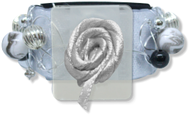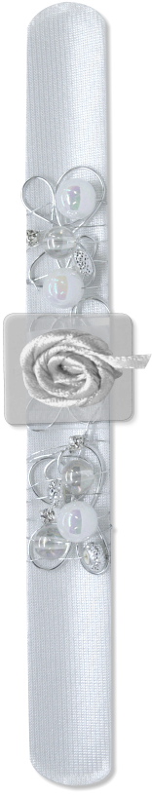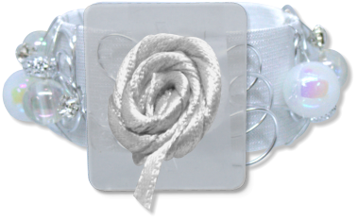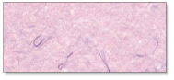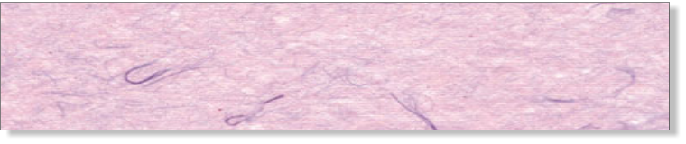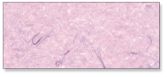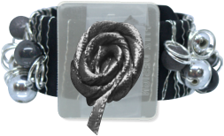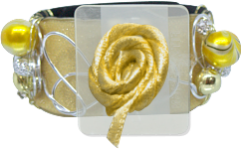

Company

123 Main St

Anytown, USA 12345

Tel: 123-456-7890

Fax: 234-567-8901

**WHITE**

**AN1912**

**BLACK**

**AN1910**

**IVORY**

**AN1911**

**GOLD**

**AN1908**

**SILVER**

**AN1907**

**NOTICE: The designs of ANGELYN BRACELETS is protected under U.S. Copyright Laws,**

**the Universal Copyright and Berne Conventions**

©Floral Marketing, LLC d/b/a Fitz Design. All Rights Reserved.

$2.25

ANGELYN BRACELETS

*EACH ONE, A UNIQUE PIECE OF CRAFTWORK*

$0.00