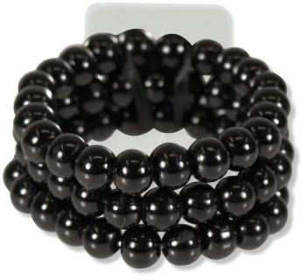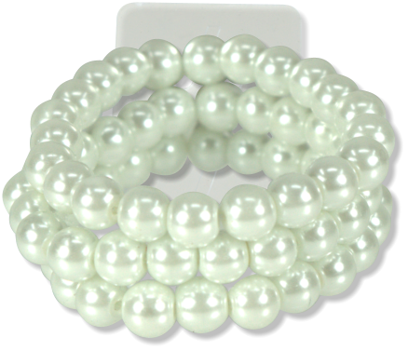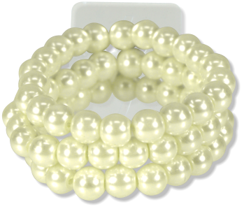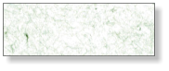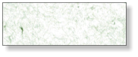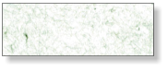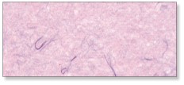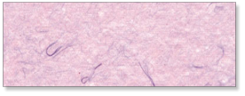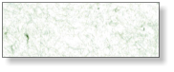

Company

123 Main St

Anytown, USA 12345

Tel: 123-456-7890

Fax: 234-567-8901

**LICORICE**

**AV1110**

**CHAMPAGNE**

**AV1111**

**SUGAR**

**AV1112**

$0.00

AVERY

**ROSE GOLD**

**AV1108R**