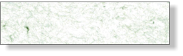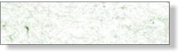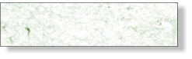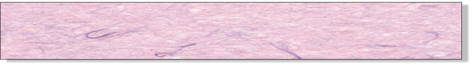

IVORY

SUGAR

IVORY (2)

ROSE GOLD (1)

CHARCOAL (1)

SUGAR (2)

Company

123 Main St

Anytown, USA 12345

Tel: 123-456-7890

Fax: 234-567-8901

BOXES OF 6

BOXES OF 6

BOXES OF 6

**IVORY BEADED**

**FD1711S**

**SUGAR BEADED**

**FD1712S**

$00.00

$00.00

$00.00

**BEADED ASSORTMENT**

**FD1799S**

BEADED BRACELETS WITH BOWS