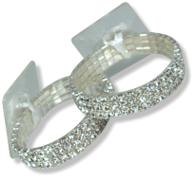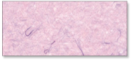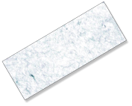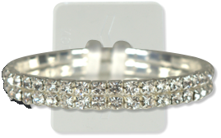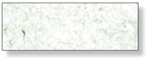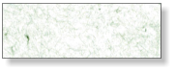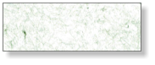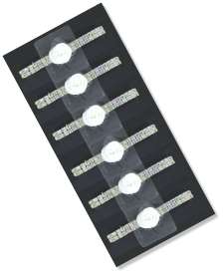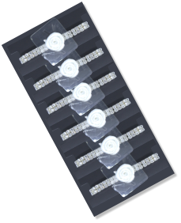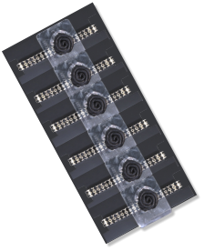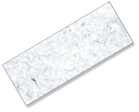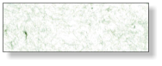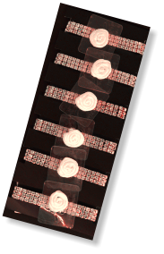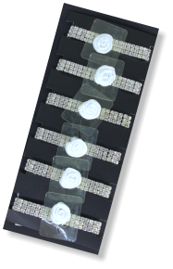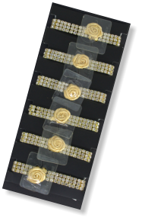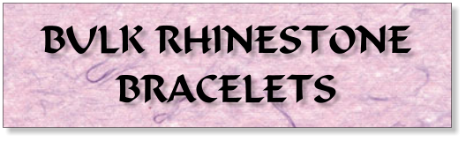

$0.00

NEW!

**ONYX**

**SL1010BULK**

**IRIDESCENT**

**SL1007BULK**

**DAZZLE**

**SL1003BULK**

Company

123 Main St

Anytown, USA 12345

Tel: 123-456-7890

Fax: 234-567-8901

NEW!

$0.00

**ROSE GOLD**

**PR1808RBULK**

**DAZZLE**

**PR1803BULK**

**24 KARAT**

**PR1808BULK**