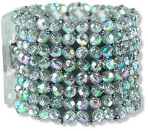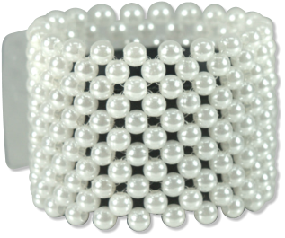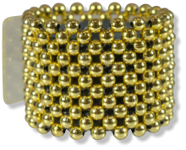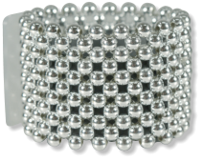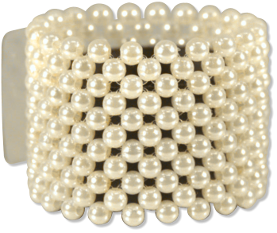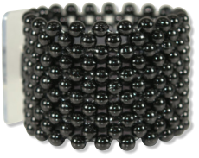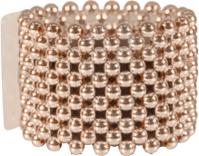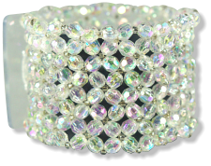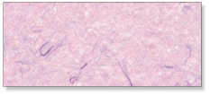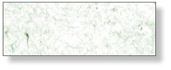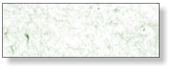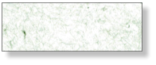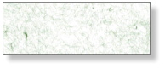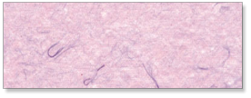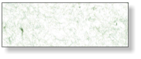

Company

123 Main St

Anytown, USA 12345

Tel: 123-456-7890

Fax: 234-567-8901

$0.00

**ICE**

**R101**

**ROSE GOLD**

**R108R**

**SUGAR**

**R112**

**GOLD**

**R108**

**LICORICE**

**R106**

**STERLING**

**R107**

**PEPPER**

**R110**

CLASSIC

**CHAMPAGNE**

**R111**