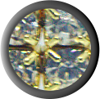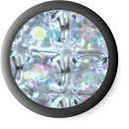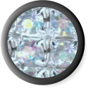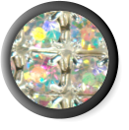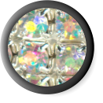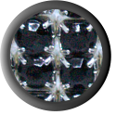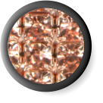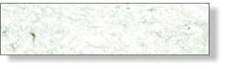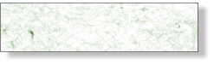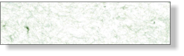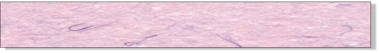

GOLD (1)

DAZZLE (2)

DAZZLE

IRIDESCENT

IRIDESCENT(1)

ONYX (1)

ROSE GOLD (1)

**DAZZLE RHINESTONE**

**FD5003S**

**IRIDESCENT RHINESTONE**

**FD5007S**

**RHINESTONE ASSORTMENT**

**FD5099S**

Company

123 Main St

Anytown, USA 12345

Tel: 123-456-7890

Fax: 234-567-8901

BOXES OF 6

BOXES OF 6

BOXES OF 6

$00.00

$00.00

$00.00

RHINESTONE BRACELETS WITH BOWS