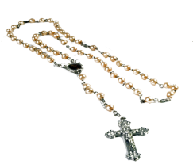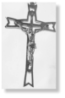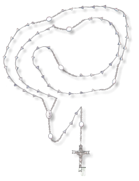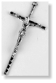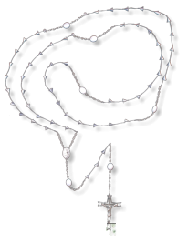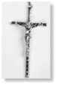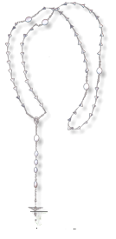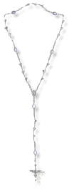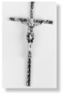

**FREE Keepsake**

**Rosary with every**

**Eternal Rosary**

**to give as a gift**

**to your client**

**ROSARY FOR 53 FLOWERS**

**LARGE CRUCIFIX**

**ER1007**

**7 FEET LONG**

**ROSARY FOR 53 FLOWERS**

**SMALL CRUCIFIX**

**ER1107**

**7 FEET LONG**

**ROSARY FOR 50 FLOWERS**

**SMALL CRUCIFIX**

**ER1207**

**7 FEET LONG**

**ROSARY FOR 18 FLOWERS**

**SMALL CRUCIFIX**

**ER1307**

**3 FEET LONG**

$00.00

$00.00

$00.00

Company

123 Main St

Anytown, USA 12345

Tel: 123-456-7890

Fax: 234-567-8901

$00.00

ETERNAL ROSARIES