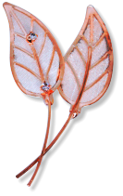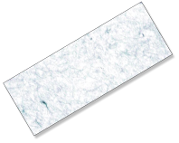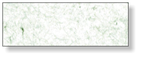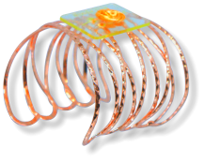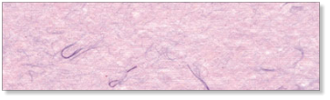

NEW!

NEW!

Company

123 Main St

Anytown, USA 12345

Tel: 123-456-7890

Fax: 234-567-8901

**ROSE GOLD**

**MA3880-RG**

**2.25” SIZE - 50 LEAVES PER PACKAGE**

$0.00

GLITTER LEAVES

$0.00

**ROCK CANDY**

**RC208R**

$0.00

**SOPHISTICATED LADY**

**SL1008R**

$0.00

**WINDSOR**

**WD1908R**

$0.00

**ALL THAT JAZZ**

**AT1908R**

**6 WITH RHINESTONE - 6 WITHOUT**

$0.00

GLEAMING LEAVES

**2.75” ROSE GOLD**

**GL1108R**

$0.00

$0.00

$0.00

NEW!

**ATHENA**

**AT1108R**

**AVERY**

**AV1108R**

**NINA CUFF**

**NI1208R**